
National University of Technology

Machine Learning Lab- CS3504

LAB Submitted to:

Lec.Hajra Ahmad

Submitted By:
Muhammad Abdullah

Reg. No: F22607010
Batch: Fall AI 2022
OEL Lab : 02
Q.NO.1:
import gym
import matplotlib.pyplot as plt

# Loading the CartPole environment
env = gym.make("CartPole-v1")
state = env.reset()

# state space and action space
print("State Space:", env.observation_space)
print("Action Space:", env.action_space)

# interacting with the environment
for _ in range(10):
action = env.action_space.sample() # Random action
next_state, reward, done, info = env.step(action)
print(f"Next State: {next_state}, Reward: {reward}, Done: {done}")
if done:
break
env.close()

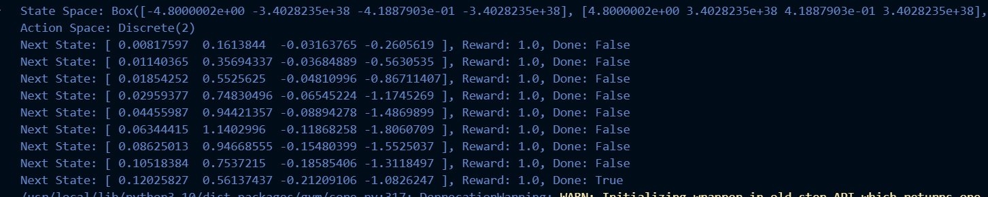

import gym
import numpy as np

# Creating the environment
env = gym.make("CartPole-v1")

# Discretizing the state space
num_bins = [6, 6, 6, 6] # Number of bins for each state feature
state_bins = [
np.linspace(-4.8, 4.8, num_bins[0] - 1),
np.linspace(-4, 4, num_bins[1] - 1),
np.linspace(-0.418, 0.418, num_bins[2] - 1),
np.linspace(-3.5, 3.5, num_bins[3] - 1),
]

def discretize_state(state):
"""Convert continuous state into a discrete one."""
discretized_state = []
for i, feature in enumerate(state):
discretized_state.append(np.digitize(feature, state_bins[i]))
return tuple(discretized_state)

# Initializing Q-table
state_space_size = tuple(num_bins)
action_space_size = env.action_space.n
q_table = np.zeros(state_space_size + (action_space_size,))

# Parameters
learning_rate = 0.1
discount_factor = 0.99
epsilon = 1.0
epsilon_decay = 0.995
min_epsilon = 0.01
episodes = 500

# Storing rewards for each episode
rewards_per_episode = []

for episode in range(episodes):
state = discretize_state(env.reset())
done = False
total_reward = 0

while not done:
# Epsilon-greedy policy
if np.random.random() < epsilon:
action = env.action_space.sample()
else:
action = np.argmax(q_table[state])

next_state, reward, done, _ = env.step(action)
next_state = discretize_state(next_state)

# Update Q-value
q_table[state + (action,)] += learning_rate * (
reward + discount_factor * np.max(q_table[next_state]) - q_table[state + (action,)]
)

state = next_state
total_reward += reward

rewards_per_episode.append(total_reward) # Append total reward for this episode
epsilon = max(min_epsilon, epsilon * epsilon_decay)
print(f"Episode: {episode + 1}, Total Reward: {total_reward}")

env.close()

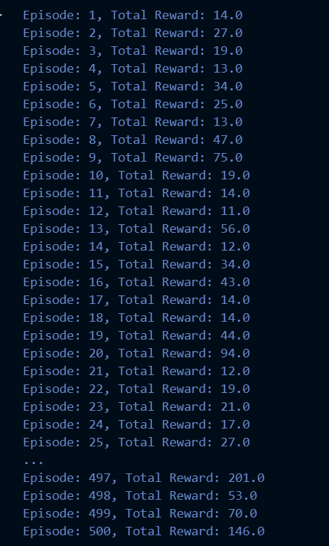

def evaluate_agent(env, q_table, episodes=100):
total_rewards = []

for _ in range(episodes):
state = discretize_state(env.reset())
done = False
episode_reward = 0

while not done:
action = np.argmax(q_table[state])
next_state, reward, done, _ = env.step(action)
next_state = discretize_state(next_state)
episode_reward += reward
state = next_state

total_rewards.append(episode_reward)

print(f"Average Reward over {episodes} episodes: {np.mean(total_rewards)}")

evaluate_agent(env, q_table)

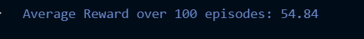

# Ploting learning curve
plt.figure(figsize=(10, 6))
plt.plot(rewards_per_episode, label="Total Reward per Episode")
plt.xlabel("Episode")
plt.ylabel("Total Reward")
plt.title("Learning Curve for Q-Learning Agent")
plt.legend()
plt.grid()
plt.show()


